Watts Supplier Portal Usage for Suppliers

Watts is using Harrington Group International’s HQMS program to manage supplier quality. HQMS is a two part web-based application: an area where Watts employees login and an area where suppliers login. As a supplier, you can create Deviation Requests, complete 8D Correction Action records that are created by Watts, and add Material Certifications to your parts.

Supplier Portal Site: https://sp.hgihost.com/watts

Web Browser compatibility: users / suppliers access the Supplier Portal with their web browser. All modern web browsers are supported – Internet Explorer, Chrome, Firefox, Safari, Microsoft Edge, and mobile. If you use Internet Explorer, it must be version 8 or later. If you have IE version 8, some of the visual elements appear different, but the site is still functional.

A Watts employee will send you an account creation / login invitation to the Supplier Portal Site. After you create your account, you may login to the Supplier Portal. The first person at your company that creates a Supplier Portal account becomes the Administrative Contact. The Administrative Contact can add other users to the Portal.

Once you establish your Portal account, you will only have access to your company’s records through the Portal. Suppliers cannot view other suppliers’ records.

Logout: when you finish viewing information in the Supplier Portal, click the Logout button on the left.

Topics List
Supplier Portal Account Creation 2
Add Supplier Portal Users 3
Add Part / Material Certification(s) 5
Deviation Records 8
Create a Deviation record 8
Deviation Attachments 11
Review and print Deviation 11
Review all Deviation records 14
8D Corrective Action 15
Update 8D Corrective Action record 15
Attachments 17
Complete the 8D Corrective Action Record 18
Review all 8D Records 20

Supplier Portal Account Creation
As mentioned above, a Watts employee will send you an email invitation to the Supplier Portal. Click the Registration link in the email to create your account.

Email example:
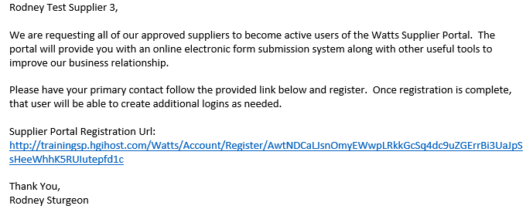

The above link will display the page / form below:
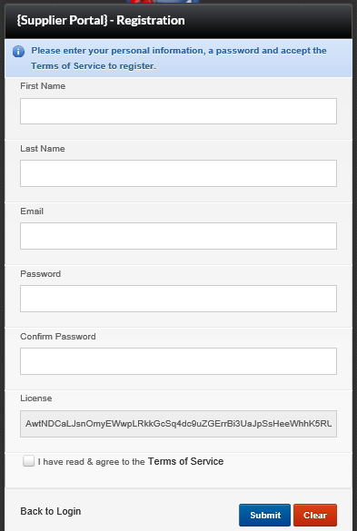
Instructions for the form above:
Type your name in the First Name and Last Name fields.
Important: the Email field is also your login ID.
Set a password and confirm it.
Check the box to agree to the Terms of Service and then click Submit.

When you login to the Portal, you will see the screen below:
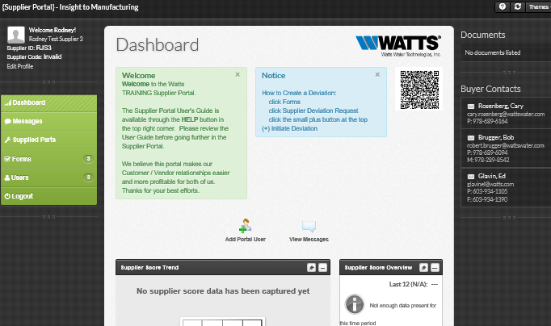

Return to topics list

Add Supplier Portal Users
You may add your team members to your Portal. They will each have their own login and can view the same information.

Add a portal user:
- Click Users on the left and then click Portal Users
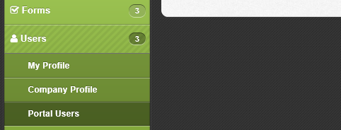
- Click the + / Add User button at the top:
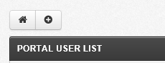

- Fill in their details, including the email address and then click Save:
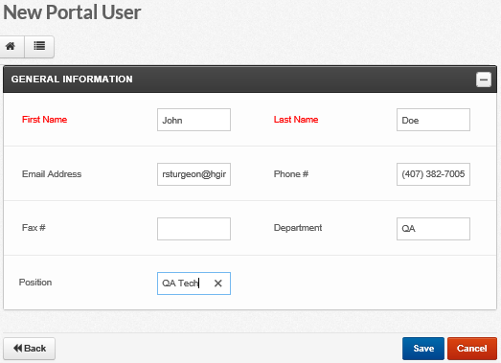

- The above user will receive a registration email. That user will click the registration link and setup their account. This user is not an administrative contact and cannot additional Portal users. Their only option in the Users area is to view their own Profile:
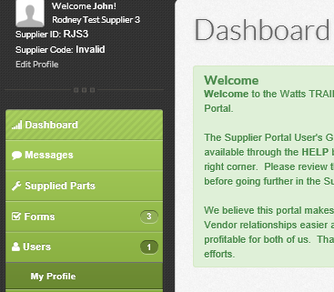
- The non-admin Portal users can still add Deviation records and Material Certifications, and manage Audits and 8D Corrective Actions.

Return to topics list

Add Part / Material Certification(s)
You can easily add your own Part / Material Certifications through the Portal.
- Click the Supplied Parts link on the left side:
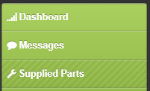

- The Portal will display a list of your supplied parts on the right:
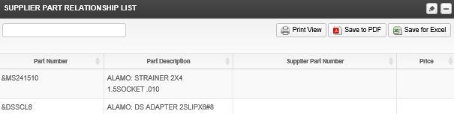

- Click a part to view its details and add a certification:
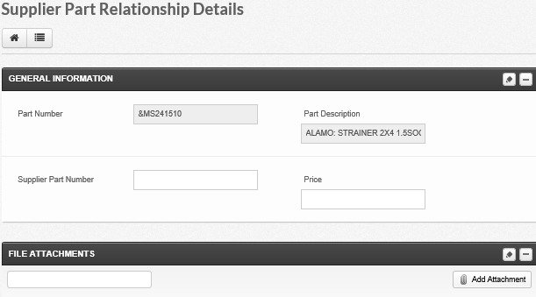
- Add a certification with the “Add Attachment” button above.
- Simply click the “Upload a file” button below:
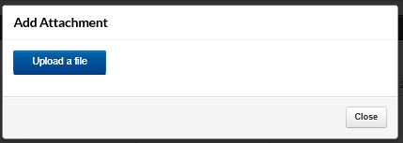

- Locate the file / material cert. and double-click it, or select it and then click Open:
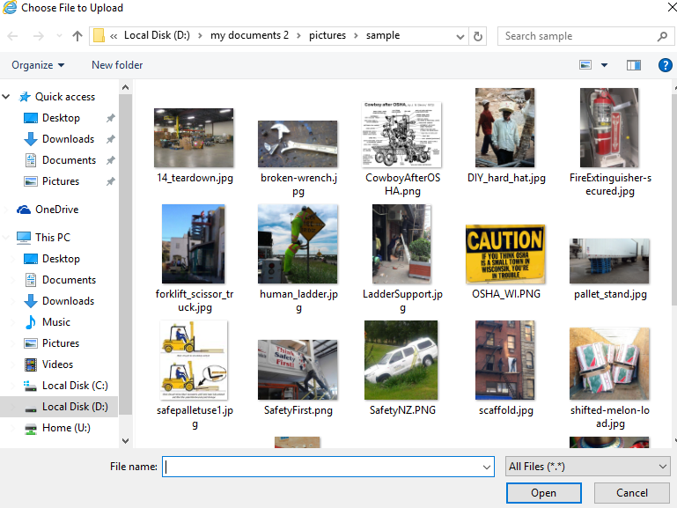

- The window will display the name of the file and its size. Click the Close button:
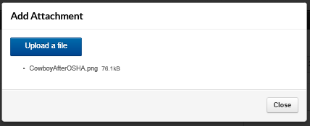
- The Part Details screen displays the Material Certifications at the bottom in the File Attachments section. Note: after the cert. is uploaded, there is no need to click the Save button on the screen below :
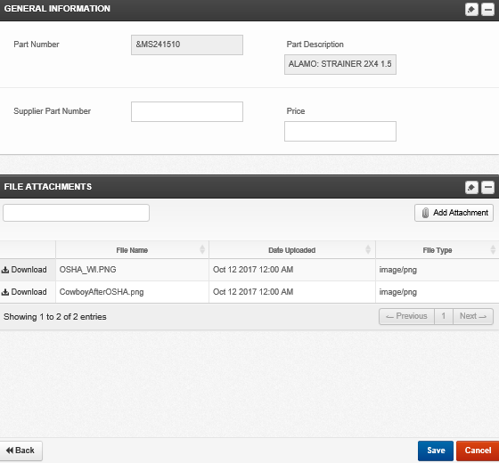
Note: click the corresponding Download button above to view the item.

- You may notify your Watts contact from the Messages area in the Portal. Click Messages on the left:
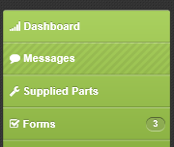

- Select your contact at the top, type your message below and then click Send:
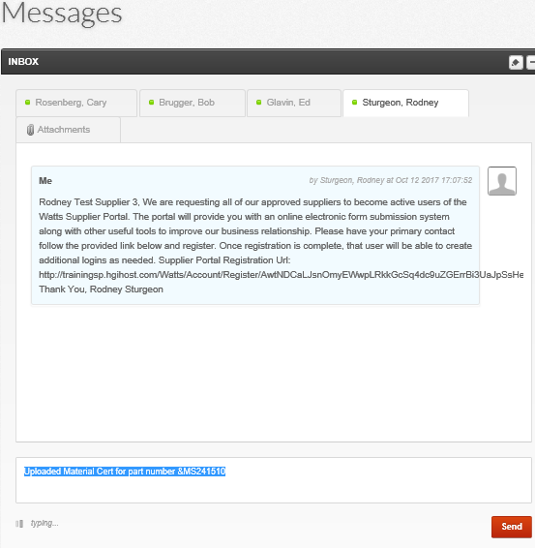

Return to topics list

Deviation Records
You will use the Supplier Portal to create your Deviation records. The Portal will automatically notify your contact at Watts upon its creation. Watts’ QA and Engineering teams will review the Deviation record and then update the system. The Portal will then notify you of whether Watts approved or rejected the Deviation.

Create a Deviation record:
- Login to the Portal and then click the Forms link on the left side:
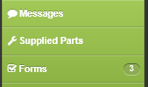

- Click Supplier Deviation Request:
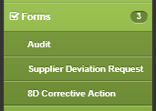

- Click the Initiate Deviation button at the top of the Deviation list:
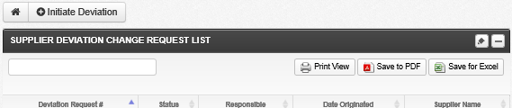

- Fill in any necessary details on the Deviation form. The three red fields are required: Subject, Request Part Number, and Supplier Delivery Location. Click Save when ready:

(screen shot on next page)
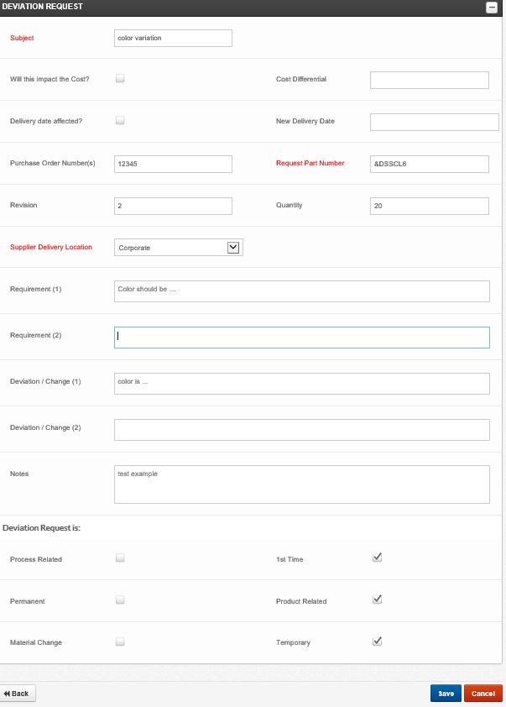

- The Portal displays a confirmation page. You may add a file attachment if necessary. If you do not need to perform any other actions in the Portal, click Logout on the left side.
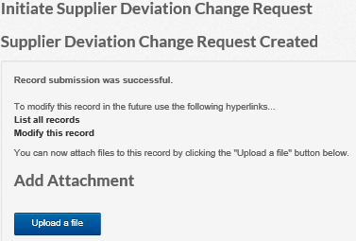

Deviation Attachments
- On the screen above, click the Upload a file button to add an attachment. Select your file and then click Open. The Portal displays the confirmation page below with the name of the file attachment and its size. There is no need to click any other save buttons at this point. If you do not need to enter any other deviations, click Logout on the left side.
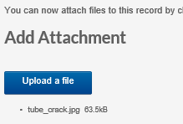

Return to topics list

Review and print Deviation:
- Watts will look at the Deviation record and either Approve or Reject it. Once Watts has made a decision, the Portal sends you an email, which includes a link to the Deviation record. Click the link to display the login page, login and then print the Deviation. Email example below:
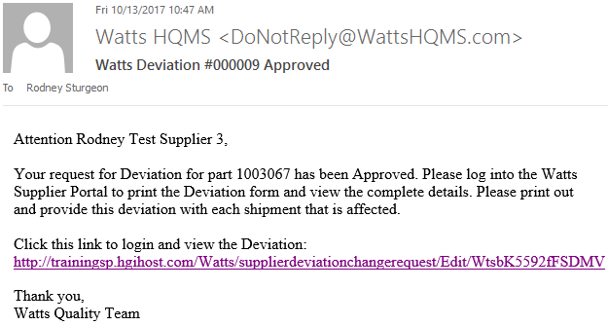

- On the Deviation Change Request Details page, you can view the Engineering Disposition and Comments towards the bottom:
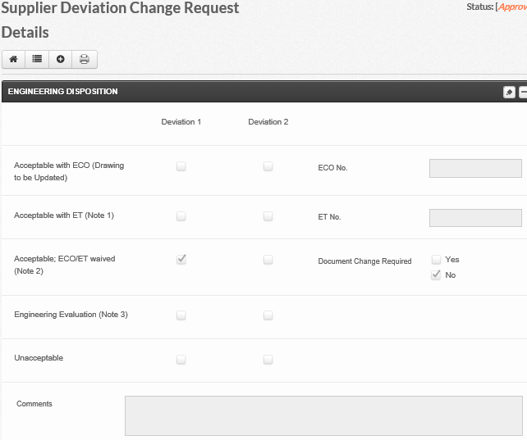
- The Portal displays the Deviation Disposition in the top right:
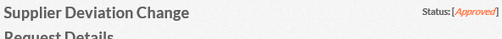

- After you review the Disposition information, print the Deviation record. Click the printer icon at the top:
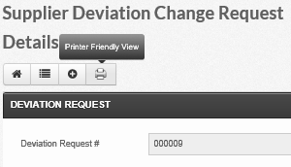

- The Portal will display the Deviation in a new tab. Use your web browser’s print function to print it. Then, close that tab to return to the Portal. If you are done, click Logout on the left. Printer friendly example:
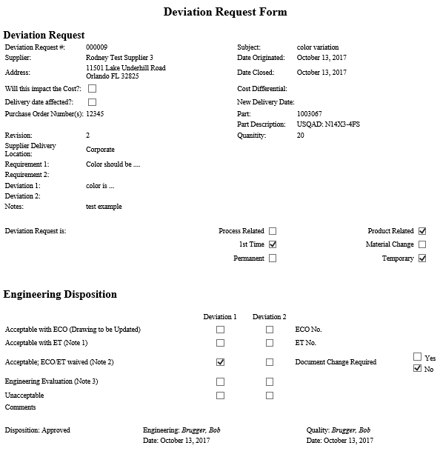

Return to topics list

Review all Deviation records:
The Supplier Portal includes a list of all Deviation records for your company. You can view open and closed Deviations. The list color-codes the deviation status to identify them as Submitted, Approved, or Rejected. Submitted are blue, Approved are green, and Rejected are red. “Submitted” deviations are still open and have not yet been approved nor rejected.
- Access the Deviation list: click Forms on the left and then click Supplier Deviation Request:
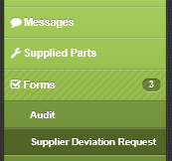

- Look to the right to see the list. By default, the Deviations are listed in order by its number:
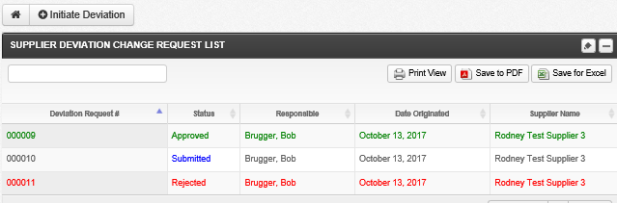

- If you want to change the sort order, simply click the column name. Click a column name a second time for a descending sort. An “up arrow” indicates ascending sort and a “down arrow” indicates descending sort. In the example below, I sorted ascending by the Status column:
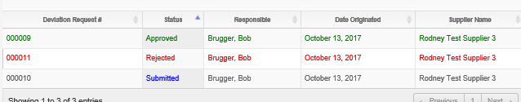

- Search for Deviations: the list includes a filter option. Simply type text or numbers in the filter field in the upper-left. For numbers, type a minimum of two characters. For text, type a minimum of three characters. Note: you can only search for information in the displayed fields: Deviation #, Status, Responsible, Date Originated, and Supplier Name. In the example below, I typed “rej” and the list displayed the one Rejected record:
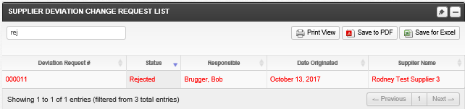

- Print and/or Export the Deviation List: use any of the three buttons in top right.
  - Print: click the Print View to display a formatted list in your browser. Use your web browser’s print function to print this list. When you are ready to return to the Portal, push the Escape key on the keyboard.
  - Save to PDF: click the Save to PDF button, the Portal displays a window where you select a save location and then click Save.
  - Save for Excel: this button creates a .CSV file. You can open that file in Excel. Click the Save for Excel button, the Portal displays a window where you select a save location and then click Save.

Return to topics list

8D Corrective Action
Watts may request your feedback / root cause / corrective action response for an 8D Corrective Action record. Watts employees create the 8D Corrective Actions. A Watts employee may notify you via email that they created an 8D record. You can login to the Supplier Portal site to view and complete your 8D records.

You do not have to complete the entire 8D record at once. Just fill in the corresponding sections when you are ready. So, if chose your corrective action, but have not yet implemented nor verified it yet, fill it out later. Click the Save button at the bottom of the page as you work through each section.

Update 8D Corrective Action record:
- Login to the Supplier Portal site. Click Forms on the left and then click 8D Corrective Action:
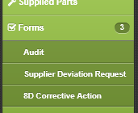
- Click an open 8D record on the list. The open records do not have a Date Closed value:
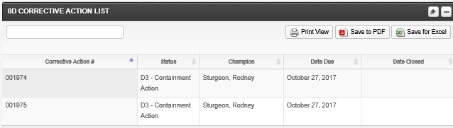

- On the 8D Detail page, you can add to and edit information in sections D3 (Containment) through D8 (Team Recognition). Simply type your information into the space provided. D3 through D7 (Prevention) each have three text boxes. It is not necessary to fill in all three boxes. For example, if you have three different Root Causes, use each text box. If there is only one Corrective Action, just use one text box.
- Suggestion: save early, save often. If you enter multiple lines of text into a text box, you may click Save before using the next text box. This will ensure that you do not lose any data.
- Below is an example 8D record where you can see sections D1 through D3:
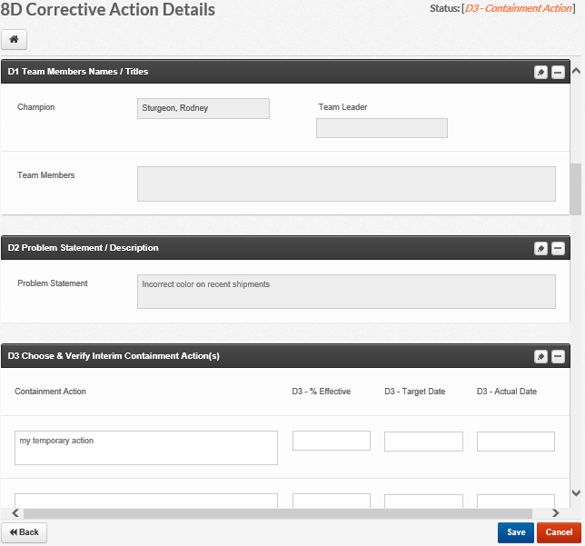

- Another example below. Notice how most of the sections include a verification box:
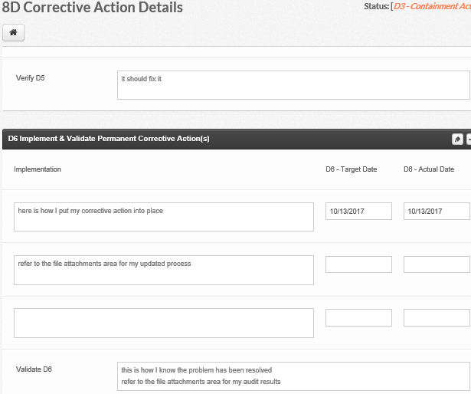

- Attachments: you can add file attachments to any 8D record. The size limit of the file is around 30MB, but you can upload any type of file. Use this as a verification of your actions and/or process changes. You may also view attachments that Watts has added. Scroll to the bottom of the 8D record for the File Attachments section.
- Add Attachment: click the Add Attachment button, click the “Upload a file” button, find your file and double-click it, the pop-up window displays the name of the file and its size, click the Close button. Below is an example screenshot after I uploaded a file:
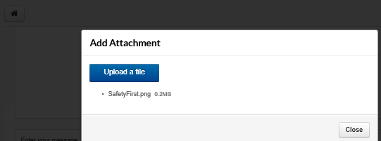

- View Attachments: the 8D record displays all of the file attachments in a table at the bottom of the record. Click the Download link to view one:
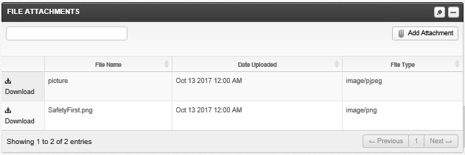

Return to topics list

Complete the 8D Corrective Action Record:
- Once you have completed your 8D investigation and verification, send an email to your Watts contact. Or, you can utilize the Portal Discussion section.
- Portal Discussion: scroll towards the bottom of the 8D record to the Discussion section. Type your message in the text box that says “Enter your message…”:
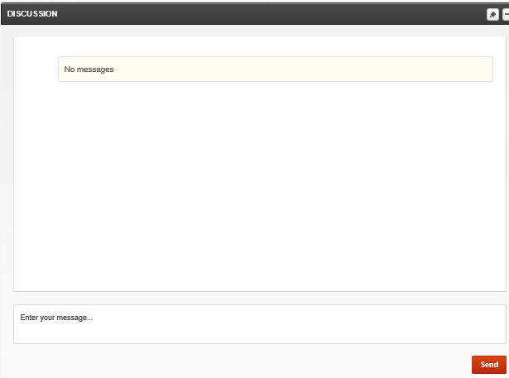

- Click the Send button when you are ready and then the 8D record will display your message:
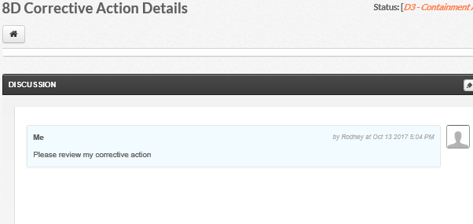

- A Watts employee will review and close the 8D record. When they close it, the system will send you an email:
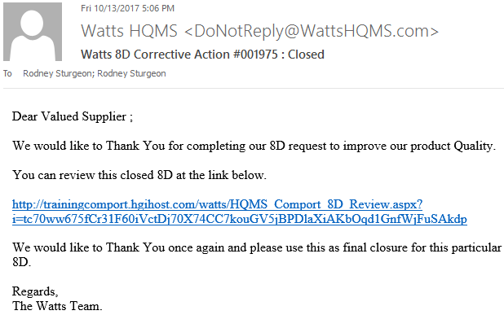

Return to topics list

Review all 8D Records
The Supplier Portal includes a list of all 8D records for your company. You can view open and closed 8Ds.
- Access the 8DCorrective Action list: click Forms on the left and then click 8D Corrective Action:
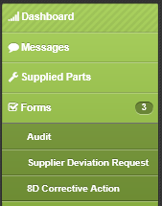

- Look to the right to see the list. By default, the 8Ds are listed in order by its number:
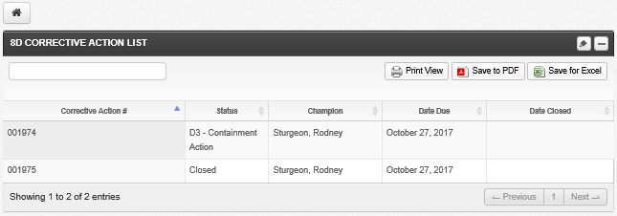

- If you want to change the sort order, simply click the column name. Click a column name a second time for a descending sort. An “up arrow” indicates ascending sort and a “down arrow” indicates descending sort. In the example below, I sorted descending by the Status column:
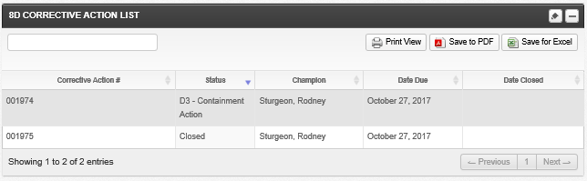

- Search for 8Ds: the list includes a filter option. Simply type text or numbers in the filter field in the upper-left. For numbers, type a minimum of two characters. For text, type a minimum of three characters. Note: you can only search for information in the displayed fields: Corrective Action #, Status, Champion, Date Due, and Date Closed. In the example below, I typed “clo” and the list displayed the one Closed record:
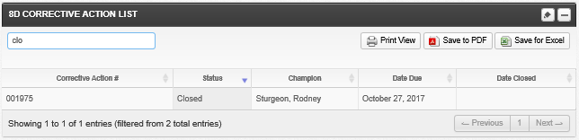

- Print and/or Export the 8D List: use any of the three buttons in top right.
  - Print: click the Print View to display a formatted list in your browser. Use your web browser’s print function to print this list. When you are ready to return to the Portal, push the Escape key on the keyboard.
  - Save to PDF: click the Save to PDF button, the Portal displays a window where you select a save location and then click Save.
  - Save for Excel: this button creates a .CSV file. You can open that file in Excel. Click the Save for Excel button, the Portal displays a window where you select a save location and then click Save.

Return to topics list

